***FITTRACKER PRO DOCUMENTATION***

***OVERVIEW:***

FitTracker Pro is a basic AWS Web application that allows the user to track their web applications through a static, yet secure website. The website is hosted via a public Amazon S3 bucket. As the project evolves, it will be hosted via AWS Amplify with a proper domain name. It is protected with AWS WAF, AWS Shield, and the built-in encryption options within the S3 settings. The app stores data in a DynamoDB, NoSQL database table with the help of AWS Lambda functions written in Python. The purpose of FitTracker Pro was to provide an easy, yet simplistic way for me to track my workouts, reps, and sets to see the progress throughout the weeks to improve in the gym. AI features, such as prompting will be coming in the future to provide live feedback to the user to provide advice as to how to improve throughout the week.

***FRONT-END***

The very-basic frontend was designed to provide a minimalistic interface to not overwhelm the user with features or bright colors. It was designed to be as simplistic as possible for the average user to easily navigate and use the website. A more modern-minimalistic interface will be in the works as the months come along.

***CHALLENGES***

Something I learned rather quickly with AWS is that every little thing needs a role, or a permission granted. I had to grant my Lambda function/role (import_data) permissions to have full access to my DynamoDB table as shown below:

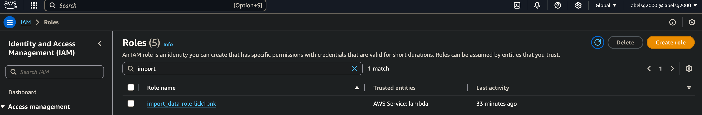

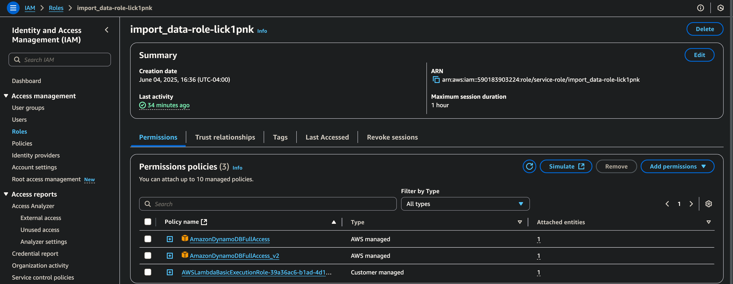

A lot of my challenges came with having to debug my import_data code within AWS Lambda. I was able to narrow down that my permissions were the issue. AWS very heavily relies on the principle of “grant least privilege”, so you always have to keep in mind to explicitly grant the permissions of everything you are trying to do, which can be frustrating. I also had to allow CORS:

* Access-Control-Allow-Origin: *
* Access-Control-Allow-Headers: Content-Type
* Access-Control-Allow-Methods: POST, GET

And deploy.

***STEPS TO CONFIGURE***